Scott Levine

Egg Fights

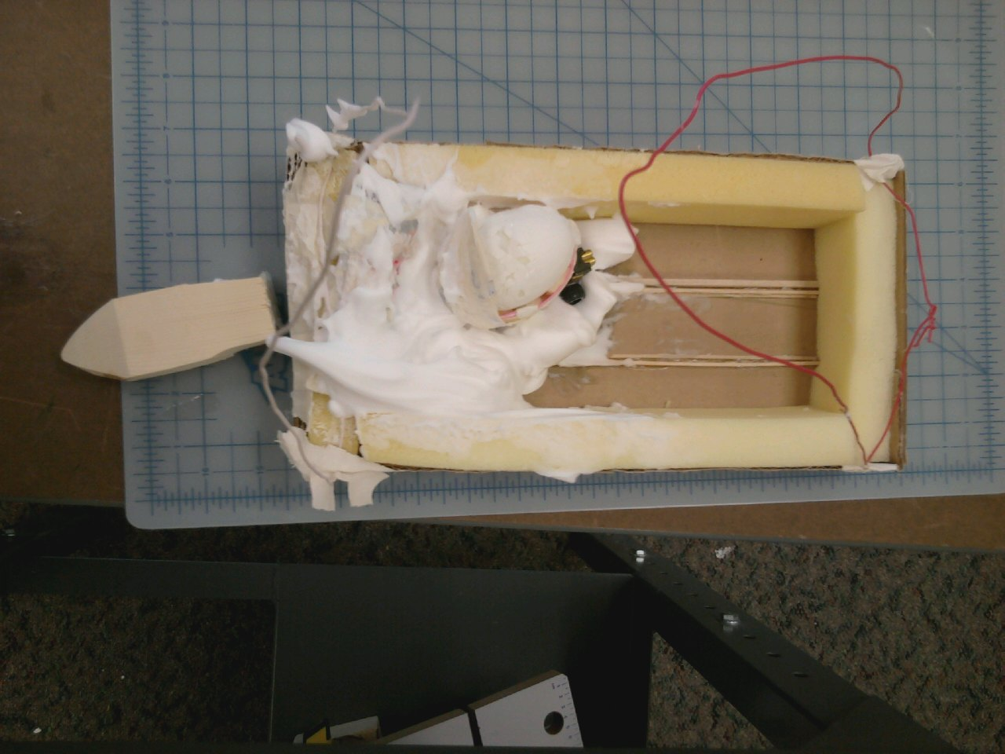

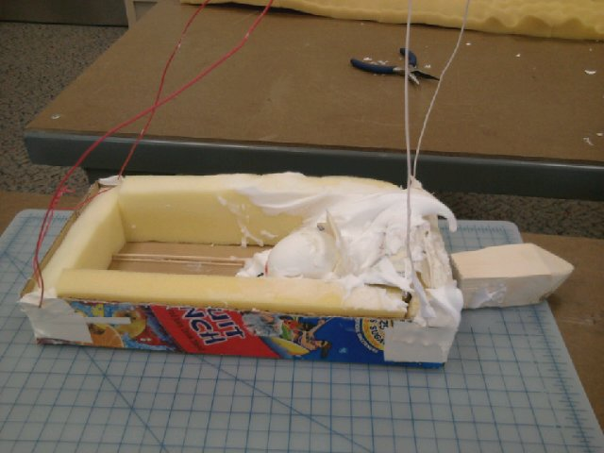 Our egg car was amazing. We only lost, because everyone else cheated, but that is besides the point. If there was one issue we had it would be that the attachment to the ceiling did not work as well as we had hoped. It came in a little off center. Then after impact half of the cart tipped over, but the shaving cream caught the egg and cushioned it. The way our vehicle was supposed to work was that : the egg would sit on the wheels and then on impact would slide along the track to be cushioned by the shaving crème and pudding. Everything worked properly, except for the fact that the other kids illegal claw landed on it. We did very well and we would not change very much at all.