Technology Education Department
Name Mitchell Wilde Introduction to Technical Drawing

STUDY QUESTIONS FOR STEP 4

1. List three (3) uses for freehand sketches:
Sketching is a freehand drawing process that allows detailers, designers, engineers, architects, technicians and trades persons to record their ideas quickly on paper without the use of tools. Once they have recorded their ideas, they can revise and refine their sketches for presentation to their supervisors or clients. Sketching is also helpful in preliminary planning of a drawing or layout before using tools.
2. What does a "multiview sketch" show you about an object?
A multiview two dimensional (2D) sketch shows the actual shape of an object from different directions that are 90° apart. A typical multiview sketch will include views from the top, front and right side. The back, bottom and left side views are optional depending on the complexity of the objects shape

3. List the three (3) principle views that are shown on a multiview sketch:

Top View Front view Right Side view

4. List in your own words the steps to follow in the making of a multiview sketch:
Step 1 - ANALYZE THE OBJECT.
Choose the orientation. The front view is typically the view with the most detail. Study the object to determine the length, width and height. Determine the number of views ( one, two, three or more) and the types of views (top, front, right or left side). Select a proportional grid size (1/4" or 1/8") to represent a unit of measurement (1/4", 1/2" or 1") and the type of paper (plain white or graph)
Step 2 - LAYOUT THE VIEWS.
Begin at the lower left area of the sheet and place four dots or dashes vertically to represent the height and width of the object with about 1" of space between the measurements. Next, return to the lower left area of the sheet and place four dots or dashes horizontally to represent the length and width of the object with about 1" of space between the measurements. If the views do not fit in the space available, use a larger sheet of paper (11" x 17" or 17" x 22") or reduce the proportions of the views.o work on.
Step 3 - BLOCK IN THE VIEWS.
Sketch very light construction lines horizontally and vertically at the dots or dashes to establish the outline of each view. A 45° line in the upper right outline is helpful in projecting lines from the top view to the right side view.
Step 4 - LOCATE DETAILS.
Use very light construction lines to locate changes in the shape of the object and to show the location of holes or rounded corners. Be sure to extend the construction lines into the adjacent view (top to front, front to side and top to side).

Step 5 - ADD DETAILS.
Use very light construction lines to create a box that represents the diameter of holes or the radius of rounded corners. Sketch in the holes and rounded corners using 90° arcs.

Step 6 - DARKEN VISIBLE LINES.
All lines that represent visible edges of the object should be shown as solid thick lines.

Step 7 - DARKEN HIDDEN LINES.
All lines that represent interior edges or hollow portions of the object should be shown as dashed medium thick lines.

Step 8 - ADD CENTER LINES.
Use thin long and short dashed lines to locate the center of holes and arcs. NOTE: Construction lines DO NOT need to be erased as they should be drawn very lightly.

5. What does a "pictorial sketch" show you about an object?

shows the overall shape of an object from one direction

6. List the three (3) principle types of pictorial sketches:

isometric, oblique and perspective.

7. Why is the "isometric pictorial sketch" the most commonly used type of pictorial view?

The isometric is the easiest to create as actual measurements are used and the shape of arcs and circles is consistent on all surfaces.

8. What overall shape should an object have to utilize an "oblique view"?
cylindrical shaped objects

9. What does a "perspective sketch" show you about an object?
Perspective sketches provide the most realistic view of an object

10. What does a "floor plan" and an "elevation" show you about a building?
How big it is

11. List in your own words the steps to follow in the making of a pictorial sketch:
Step 1 - ANALYZE THE OBJECT.
Study the object to determine the length, width and height. Determine the type of pictorial view (isometric, oblique or perspective). Select a proportional grid size (1/4" or 1/8") to represent a unit of measurement (1/4", 1/2" or 1") and the type of paper (plain white or graph) to work on.
Step 2 - LAYOUT THE AXIS FOR AN ISOMETRIC SKETCH.
Begin at a point to the right and below the center of the sheet. At this point sketch three axis (one vertical, one to the right at a 30° angle from horizontal and one to the left at a 30° angle from horizontal). The three axis should form a "Y" on the sheet.
Step 3 - ADD DIMENSIONS TO THE AXIS.
Estimate the height on the vertical axis and mark it with a dash. Estimate the width on the axis to the right and mark it with a dash. Estimate the length on the axis to the left and mark it with a dash. If the measurements do not fit in the space available, use a larger sheet of paper (11" x 17" or 17" x 22") or reduce the proportions of the views.
Step 4 - BLOCK IN THE VIEWS.
Sketch very light construction lines parallel to the axis to form a box that the object will fit in.
Step 5 - LOCATE DETAILS.
Use very light construction lines to locate changes in the shape of the object and to show the location of holes or rounded corners.
Step 6 - ADD DETAILS.
Use very light construction lines to create a diamond that represents the diameter of holes or the radius of rounded corners. Sketch in the holes and rounded corners
Step 7 - DARKEN VISIBLE LINES.
All lines that represent visible edges of the object should be shown as solid thick lines.using one or more arcs.
Step 8 - ERASE EXCESS LINES.
Hidden lines or center lines are NOT shown.

12. Show and label with arrows the recommended methods for sketching the following lines:

Horizontal lines Vertical lines

Angular lines Circular lines

13. Sketch an example of a "construction" line and explain how it is used: a construction line is very thinly drawn line.
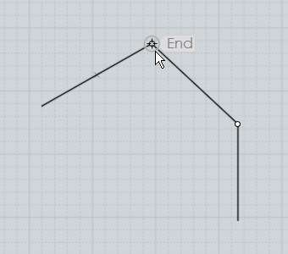

14. Sketch an example of a "visible" line and explain how it is used:
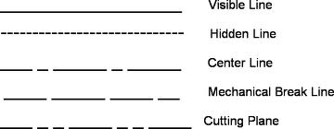

15. Sketch an example of a "hidden" line and explain how it is used:
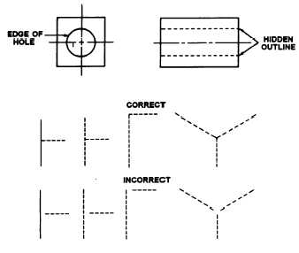

16. Sketch an example of a "center" line and explain how it is used:
It is used to measure the inside of a circle
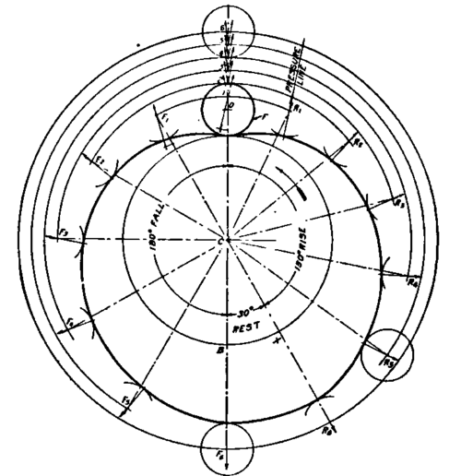

17. Is it necessary to erase "construction" lines? Explain Yes because it helps with the layout of the work

18. What shape does a circle become when sketched on a pictorial view?

A sphere

19. Is it necessary to sketch objects in the proper "proportions"? yes

Explain: So you can tell how big objects are in comparison to people

20. Make freehand sketches of the following using appropriate "proportions" in the space below :

1" x 2" rectangle two 1.5" parallel lines 1/2" apart

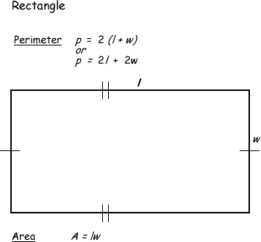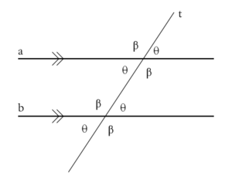

two 3/4" perpendicular lines 1.5" diameter circle

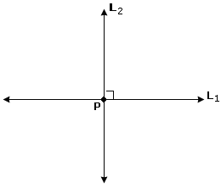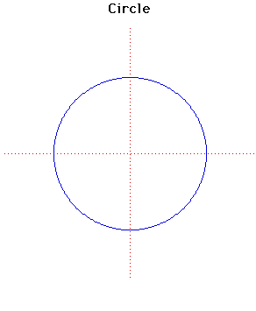

2" isometric ellipse
