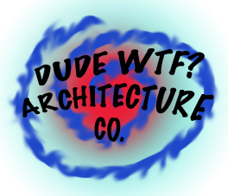

**DUDE WTF ARCHITECTURE, CO.**

**DooD We are Teh Best**

**Lincolnshire, IL 60069**

**847-101-1337**