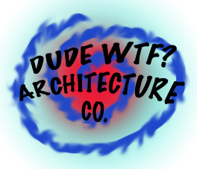**DUDE WTF**

**ARCHITECTURE CO.**

**1337 AWESOME DRIVE**

**LINCOLNSHIRE, IL 60069**